2. Problem Statement
Problem Statement:
● Explain the below concepts with an example in brief.

● Nosql Databases

A NoSQL (originally referring to "non SQL" or "non relational") database provides a mechanism for storage and retrieval of data that is modeled in means other than the tabular relations used in relational databases. Such databases have existed since the late 1960s, but did not obtain the "NoSQL" moniker until a surge of popularity in the early twenty-first century, triggered by the needs of Web 2.0 companies such as Facebook, Google, and Amazon.com.NoSQL databases are increasingly used in big data and real-time web applications.NoSQL systems are also sometimes called "Not only SQL" to emphasize that they may support SQL-like query languages.
Motivations for this approach include: simplicity of design, simpler "horizontal" scaling to clusters of machines (which is a problem for relational databases),[2] and finer control over availability. The data structures used by NoSQL databases (e.g. key-value, wide column, graph, or document) are different from those used by default in relational databases, making some operations faster in NoSQL. The particular suitability of a given NoSQL database depends on the problem it must solve. Sometimes the data structures used by NoSQL databases are also viewed as "more flexible" than relational database tables.
Many NoSQL stores compromise consistency (in the sense of the CAP theorem) in favor of availability, partition tolerance, and speed. Barriers to the greater adoption of NoSQL stores include the use of low-level query languages (instead of SQL, for instance the lack of ability to perform ad-hoc joins across tables), lack of standardized interfaces, and huge previous investments in existing relational databases.[10] Most NoSQL stores lack true ACID transactions, although a few databases, such as MarkLogic, Aerospike, FairCom c-treeACE, Google Spanner (though technically a NewSQL database), Symas LMDB, and OrientDB have made them central to their designs. (See ACID and join support.)
Instead, most NoSQL databases offer a concept of "eventual consistency" in which database changes are propagated to all nodes "eventually" (typically within milliseconds) so queries for data might not return updated data immediately or might result in reading data that is not accurate, a problem known as stale reads.Additionally, some NoSQL systems may exhibit lost writes and other forms of data loss. Fortunately, some NoSQL systems provide concepts such as write-ahead logging to avoid data loss. For distributed transaction processing across multiple databases, data consistency is an even bigger challenge that is difficult for both NoSQL and relational databases. Even current relational databases "do not allow referential integrity constraints to span databases." There are few systems that maintain both ACID transactions and X/Open XA standards for distributed transaction processing.
The term NoSQL was used by Carlo Strozzi in 1998 to name his lightweight, Strozzi NoSQL open-source relational database that did not expose the standard Structured Query Language (SQL) interface, but was still relational.[16] His NoSQL RDBMS is distinct from the circa-2009 general concept of NoSQL databases. Strozzi suggests that, because the current NoSQL movement "departs from the relational model altogether, it should therefore have been called more appropriately 'NoREL',[17] referring to 'No Relational'.
Johan Oskarsson, then a developer at Last.fm, reintroduced the term NoSQL in early 2009 when he organized an event to discuss "open source distributed, non relational databases". The name attempted to label the emergence of an increasing number of non-relational, distributed data stores, including open source clones of Google's BigTable/MapReduce and Amazon's Dynamo. Most of the early NoSQL systems did not attempt to provide atomicity, consistency, isolation and durability guarantees, contrary to the prevailing practice among relational database systems.
Morteza Sargolzaei Javan, a researcher at Amirkabir University of Technology, used the term "Multi Dimensional and Flexible Model for Databases" in late 2009 with a visualized representation and sample application. He mentioned that such models are able to process new operations during designing or even running time of the databases.

Types and examples of NoSQL databases[edit]
There have been various approaches to classify NoSQL databases, each with different categories and subcategories, some of which overlap. What follows is a basic classification by data model, with examples:
- Column: Accumulo, Cassandra, Druid, HBase, Vertica.
- Document: Apache CouchDB, ArangoDB, BaseX, Clusterpoint, Couchbase, Cosmos DB, HyperDex, IBM Domino, MarkLogic, MongoDB, OrientDB, Qizx, RethinkDB
- Key-value: Aerospike, Apache Ignite, ArangoDB, Couchbase, Dynamo, FairCom c-treeACE, FoundationDB, HyperDex, InfinityDB, MemcacheDB, MUMPS, Oracle NoSQL Database, OrientDB, Redis, Riak, Berkeley DB, SDBM/Flat File dbm
- Graph: AllegroGraph, ArangoDB, InfiniteGraph, Apache Giraph, MarkLogic, Neo4J, OrientDB, Virtuoso
- Multi-model: Apache Ignite, ArangoDB, Couchbase, FoundationDB, InfinityDB, MarkLogic, OrientDB
A more detailed classification is the following, based on one from Stephen Yen:
Type | Examples of this type
Key-Value Cache | Apache Ignite, Coherence, eXtreme Scale, Hazelcast, Infinispan, JBoss Cache, Memcached, Repcached, Velocity
Key-Value Store | ArangoDB, Flare, Keyspace, RAMCloud, SchemaFree, Hyperdex, Aerospike, quasardb
Key-Value Store (Eventually-Consistent) | DovetailDB, Oracle NoSQL Database, Dynamo, Riak, Dynomite, Voldemort, SubRecord
Key-Value Store (Ordered) | Actord, FoundationDB, InfinityDB, Lightcloud, LMDB, Luxio, MemcacheDB, NMDB, TokyoTyrant
Data-Structures Server | Redis
Tuple Store | Apache River, Coord, GigaSpaces
Object Database | DB4O, Objectivity/DB, Perst, Shoal, ZopeDB
Document Store | ArangoDB, BaseX, Clusterpoint, Couchbase, CouchDB, DocumentDB, IBM Domino, MarkLogic, MongoDB, Qizx, RethinkDB
Wide Column Store | Amazon DynamoDB, BigTable, Cassandra, Druid, HBase, Hypertable, KAI, KDI, OpenNeptune, Qbase
Correlation databases are model-independent, and instead of row-based or column-based storage, use value-based storage.

Key-value store[edit]
Main article: Key-value database
Key-value (KV) stores use the associative array (also known as a map or dictionary) as their fundamental data model. In this model, data is represented as a collection of key-value pairs, such that each possible key appears at most once in the collection.
The key-value model is one of the simplest non-trivial data models, and richer data models are often implemented as an extension of it. The key-value model can be extended to a discretely ordered model that maintains keys in lexicographic order. This extension is computationally powerful, in that it can efficiently retrieve selective key ranges.
Key-value stores can use consistency models ranging from eventual consistency to serializability. Some databases support ordering of keys. There are various hardware implementations, and some users maintain data in memory (RAM), while others employ solid-state drives (SSD) or rotating disks (aka Hard Disk Drive (HDD)).
Examples include ArangoDB, InfinityDB, Oracle NoSQL Database, Redis, and dbm.

● Types of Nosql Databases

Types of NoSQL databases-
There are 4 basic types of NoSQL databases:
- Key-Value Store – It has a Big Hash Table of keys & values {Example- Riak, Amazon S3 (Dynamo)}
- Document-based Store- It stores documents made up of tagged elements. {Example- CouchDB}
- Column-based Store- Each storage block contains data from only one column, {Example- HBase, Cassandra}
- Graph-based-A network database that uses edges and nodes to represent and store data. {Example- Neo4J}
1. Key Value Store NoSQL Database
The schema-less format of a key value database like Riak is just about what you need for your storage needs. The key can be synthetic or auto-generated while the value can be String, JSON, BLOB (basic large object) etc.
The key value type basically, uses a hash table in which there exists a unique key and a pointer to a particular item of data. A bucket is a logical group of keys – but they don’t physically group the data. There can be identical keys in different buckets.
Performance is enhanced to a great degree because of the cache mechanisms that accompany the mappings. To read a value you need to know both the key and the bucket because the real key is a hash (Bucket+ Key).
There is no complexity around the Key Value Store database model as it can be implemented in a breeze. Not an ideal method if you are only looking to just update part of a value or query the database.
When we try and reflect back on the CAP theorem, it becomes quite clear that key value stores are great around the Availability and Partition aspects but definitely lack in Consistency.
Example: Consider the data subset represented in the following table. Here the key is the name of the 3Pillar country name, while the value is a list of addresses of 3PiIllar centers in that country.
Key | Value
“India” | {“B-25, Sector-58, Noida, India – 201301”
“Romania” | {“IMPS Moara Business Center, Buftea No. 1, Cluj-Napoca, 400606″,City Business Center, Coriolan Brediceanu No. 10, Building B, Timisoara, 300011”}
“US” | {“3975 Fair Ridge Drive. Suite 200 South, Fairfax, VA 22033”}
The key can be synthetic or auto-generated while the value can be String, JSON, BLOB (basic large object) etc.
This key/value type database allow clients to read and write values using a key as follows:
- Get(key), returns the value associated with the provided key.
- Put(key, value), associates the value with the key.
- Multi-get(key1, key2, .., keyN), returns the list of values associated with the list of keys.
- Delete(key), removes the entry for the key from the data store.
While Key/value type database seems helpful in some cases, but it has some weaknesses as well. One, is that the model will not provide any kind of traditional database capabilities (such as atomicity of transactions, or consistency when multiple transactions are executed simultaneously). Such capabilities must be provided by the application itself.
Secondly, as the volume of data increases, maintaining unique values as keys may become more difficult; addressing this issue requires the introduction of some complexity in generating character strings that will remain unique among an extremely large set of keys.
- Riak and Amazon’s Dynamo are the most popular key-value store NoSQL databases.
2. Document Store NoSQL Database
The data which is a collection of key value pairs is compressed as a document store quite similar to a key-value store, but the only difference is that the values stored (referred to as “documents”) provide some structure and encoding of the managed data. XML, JSON (Java Script Object Notation), BSON (which is a binary encoding of JSON objects) are some common standard encodings.
The following example shows data values collected as a “document” representing the names of specific retail stores. Note that while the three examples all represent locations, the representative models are different.
1  2  3  4  5  6  7  8  9 | {officeName:”3Pillar Noida”,  {Street: “B-25, City:”Noida”, State:”UP”, Pincode:”201301”}  }  {officeName:”3Pillar Timisoara”,  {Boulevard:”Coriolan Brediceanu No. 10”, Block:”B, Ist Floor”, City: “Timisoara”, Pincode: 300011”}  }  {officeName:”3Pillar Cluj”,  {Latitude:”40.748328”, Longitude:”-73.985560”}  }
One key difference between a key-value store and a document store is that the latter embeds attribute metadata associated with stored content, which essentially provides a way to query the data based on the contents. For example, in the above example, one could search for all documents in which “City” is “Noida” that would deliver a result set containing all documents associated with any “3Pillar Office” that is in that particular city.
Apache CouchDB is an example of a document store. CouchDB uses JSON to store data, JavaScript as its query language using MapReduce and HTTP for an API. Data and relationships are not stored in tables as is a norm with conventional relational databases but in fact are a collection of independent documents.
The fact that document style databases are schema-less makes adding fields to JSON documents a simple task without having to define changes first.
- Couchbase and MongoDB are the most popular document based databases.
3. Column Store NoSQL Database–
In column-oriented NoSQL database, data is stored in cells grouped in columns of data rather than as rows of data. Columns are logically grouped into column families. Column families can contain a virtually unlimited number of columns that can be created at runtime or the definition of the schema. Read and write is done using columns rather than rows.
In comparison, most relational DBMS store data in rows, the benefit of storing data in columns, is fast search/ access and data aggregation. Relational databases store a single row as a continuous disk entry. Different rows are stored in different places on disk while Columnar databases store all the cells corresponding to a column as a continuous disk entry thus makes the search/access faster.
For example: To query the titles from a bunch of a million articles will be a painstaking task while using relational databases as it will go over each location to get item titles. On the other hand, with just one disk access, title of all the items can be obtained.
Data Model
- ColumnFamily: ColumnFamily is a single structure that can group Columns and SuperColumns with ease.
- Key: the permanent name of the record. Keys have different numbers of columns, so the database can scale in an irregular way.
- Keyspace: This defines the outermost level of an organization, typically the name of the application. For example, ‘3PillarDataBase’ (database name).
- Column: It has an ordered list of elements aka tuple with a name and a value defined.
The best known examples are Google’s BigTable and HBase & Cassandra that were inspired from BigTable.
BigTable, for instance is a high performance, compressed and proprietary data storage system owned by Google. It has the following attributes:
- Sparse – some cells can be empty
- Distributed – data is partitioned across many hosts
- Persistent – stored to disk
- Multidimensional – more than 1 dimension
- Map – key and value
- Sorted – maps are generally not sorted but this one is
A 2-dimensional table comprising of rows and columns is part of the relational database system.
City | Pincode | Strength | Project
Noida | 201301 | 250 | 20
Cluj | 400606 | 200 | 15
Timisoara | 300011 | 150 | 10
Fairfax | VA 22033 | 100 | 5
For above RDBMS table a BigTable map can be visualized as shown below.
1  2  3  4  5  6  7  8  9  10  11  12  13  14  15  16  17  18  19  20  21  22  23  24  25  26  27  28  29  30  31  32  33  34  35  36  37  38  39  40  41  42  43 | {  3PillarNoida: {  city: Noida  pincode: 201301  },  details: {  strength: 250  projects: 20  }  }  {  3PillarCluj: {  address: {  city: Cluj  pincode: 400606  },  details: {  strength: 200  projects: 15  }  },  {  3PillarTimisoara: {  address: {  city: Timisoara  pincode: 300011  },  details: {  strength: 150  projects: 10  }  }  {  3PillarFairfax : {  address: {  city: Fairfax  pincode: VA 22033  },  details: {  strength: 100  projects: 5  }  }
- The outermost keys 3PillarNoida, 3PillarCluj, 3PillarTimisoara and 3PillarFairfax are analogues to rows.
- ‘address’ and ‘details’ are called column families.
- The column-family ‘address’ has columns ‘city’ and ‘pincode’.
- The column-family details’ has columns ‘strength’ and ‘projects’.
Columns can be referenced using CloumnFamily.
- Google’s BigTable, HBase and Cassandra are the most popular column store based databases.
4. Graph Base NoSQL Database
In a Graph Base NoSQL Database, you will not find the rigid format of SQL or the tables and columns representation, a flexible graphical representation is instead used which is perfect to address scalability concerns. Graph structures are used with edges, nodes and properties which provides index-free adjacency. Data can be easily transformed from one model to the other using a Graph Base NoSQL database.
- These databases that uses edges and nodes to represent and store data.
- These nodes are organised by some relationships with one another, which is represented by edges between the nodes.
- Both the nodes and the relationships have some defined properties.
The following are some of the features of the graph based database, which are explained on the basis of the example below:
Labeled, directed, attributed multi-graph : The graphs contains the nodes which are labelled properly with some properties and these nodes have some relationship with one another which is shown by the directional edges. For example: in the following representation, “Alice knows Bob” is shown by an edge that also has some properties.
While relational database models can replicate the graphical ones, the edge would require a join which is a costly proposition.
UseCase–
Any ‘Recommended for You’ rating you see on e-commerce websites (book/video renting sites) is often derived by taking into account how other users have rated the product in question. Arriving at such a UseCase is made easy using Graph databases.
InfoGrid and Infinite Graph are the most popular graph based databases. InfoGrid allows the connection of as many edges (Relationships) and nodes (MeshObjects), making it easier to represent hyperlinked and complex set of information.
There are two kinds of GraphDatabase offered by InfoGrid, these include the following:
MeshBase– It is a perfect option where standalone deployment is required.
NetMeshBase – It is ideally suited for large distributed graphs and has additional capabilities to communicate with other similar NetMeshbase.
This concludes the second post exemplifying the value in a NoSQL implementation. In this blog post we discussed in detail the different types of NoSQL databases. Watch out for the concluding part of the series which will cover important factors to consider before finalizing which NoSQL database to use.

● CAP Theorem

No distributed system is safe from network failures, thus network partitioning generally has to be tolerated. In the presence of a partition, one is then left with two options: consistency or availability. When choosing consistency over availability, the system will return an error or a time-out if particular information cannot be guaranteed to be up to date due to network partitioning. When choosing availability over consistency, the system will always process the query and try to return the most recent available version of the information, even if it cannot guarantee it is up to date due to network partitioning.
In the absence of network failure – that is, when the distributed system is running normally – both availability and consistency can be satisfied.
CAP is frequently misunderstood as if one has to choose to abandon one of the three guarantees at all times. In fact, the choice is really between consistency and availability only when a network partition or failure happens; at all other times, no trade-off has to be made.
Database systems designed with traditional ACID guarantees in mind such as RDBMS choose consistency over availability, whereas systems designed around the BASEphilosophy, common in the NoSQL movement for example, choose availability over consistency.
The PACELC theorem builds on CAP by stating that even in the absence of partitioning, another trade-off between latency and consistency occurs

● HBase Architecture

HBase Architectural Components
Physically, HBase is composed of three types of servers in a master slave type of architecture. Region servers serve data for reads and writes. When accessing data, clients communicate with HBase RegionServers directly. Region assignment, DDL (create, delete tables) operations are handled by the HBase Master process. Zookeeper, which is part of HDFS, maintains a live cluster state.
The Hadoop DataNode stores the data that the Region Server is managing. All HBase data is stored in HDFS files. Region Servers are collocated with the HDFS DataNodes, which enable data locality (putting the data close to where it is needed) for the data served by the RegionServers. HBase data is local when it is written, but when a region is moved, it is not local until compaction.
The NameNode maintains metadata information for all the physical data blocks that comprise the files.
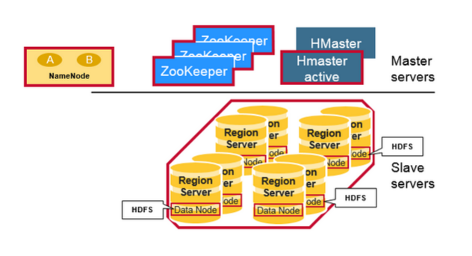

Regions
HBase Tables are divided horizontally by row key range into “Regions.” A region contains all rows in the table between the region’s start key and end key. Regions are assigned to the nodes in the cluster, called “Region Servers,” and these serve data for reads and writes. A region server can serve about 1,000 regions.
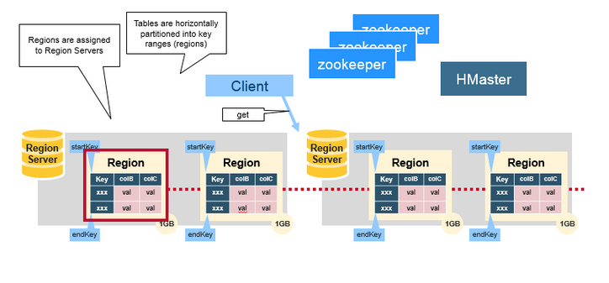

HBase HMaster
Region assignment, DDL (create, delete tables) operations are handled by the HBase Master.
A master is responsible for:

Coordinating the region servers
- Assigning regions on startup , re-assigning regions for recovery or load balancing
- Monitoring all RegionServer instances in the cluster (listens for notifications from zookeeper)
Admin functions
- Interface for creating, deleting, updating tables
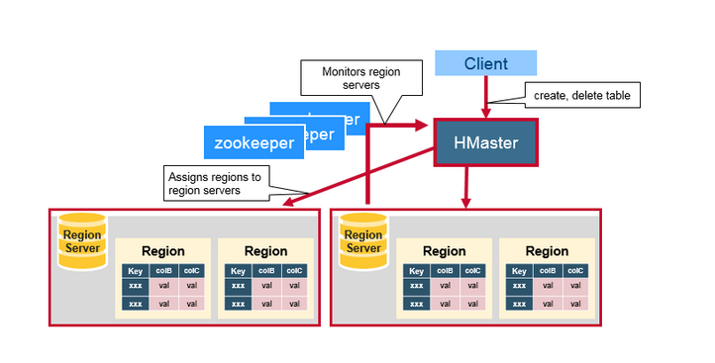

ZooKeeper: The Coordinator
HBase uses ZooKeeper as a distributed coordination service to maintain server state in the cluster. Zookeeper maintains which servers are alive and available, and provides server failure notification. Zookeeper uses consensus to guarantee common shared state. Note that there should be three or five machines for consensus.

How the Components Work Together
Zookeeper is used to coordinate shared state information for members of distributed systems. Region servers and the active HMaster connect with a session to ZooKeeper. The ZooKeeper maintains ephemeral nodes for active sessions via heartbeats.
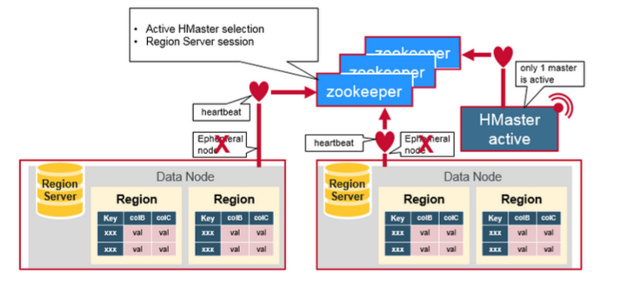
Each Region Server creates an ephemeral node. The HMaster monitors these nodes to discover available region servers, and it also monitors these nodes for server failures. HMasters vie to create an ephemeral node. Zookeeper determines the first one and uses it to make sure that only one master is active. The active HMaster sends heartbeats to Zookeeper, and the inactive HMaster listens for notifications of the active HMaster failure.
If a region server or the active HMaster fails to send a heartbeat, the session is expired and the corresponding ephemeral node is deleted. Listeners for updates will be notified of the deleted nodes. The active HMaster listens for region servers, and will recover region servers on failure. The Inactive HMaster listens for active HMaster failure, and if an active HMaster fails, the inactive HMaster becomes active.

HBase First Read or Write
There is a special HBase Catalog table called the META table, which holds the location of the regions in the cluster. ZooKeeper stores the location of the META table.
This is what happens the first time a client reads or writes to HBase:
- The client gets the Region server that hosts the META table from ZooKeeper.
- The client will query the .META. server to get the region server corresponding to the row key it wants to access. The client caches this information along with the META table location.
- It will get the Row from the corresponding Region Server.

● HBase vs RDBMS

Hadoop and RDBMS are varying concepts of processing, retrieving and storing the data or information. While Hadoop is an open-source Apache project, RDBMS stands for Relational Database Management System. Hadoop framework has been written in Java which makes it scalable and makes it able to support applications that call for high performance standards. Hadoop framework enables the storage of large amounts of data on files systems of multiple computers. Hadoop is configured to allow scalability from a single computer node to several thousands of nodes or independent workstations in a manner that the individual nodes utilize local computer storage CPU processing power and memory.
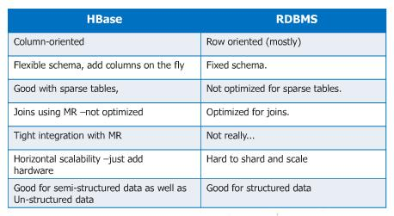
Source: www.ironsidegroup.com
Database Management Systems focus on the data storage in table form which includes columns and rows. SQL is utilized to retrieve needed data which is stored in such tables. The RDBMS concept stores relationships between such tables in various forms so that one column of entries of a particular table will act as a reference for another table. Such column values are known as primary keys and foreign keys with the keys being used to reference other existing tables so that the appropriate data can be related and also be retrieved by combining such tables using SQL queries as required. The tables and relationships can be altered by integrating relevant tables using SQL queries.
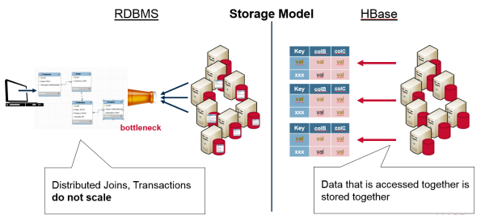
Source: mapr.com
It is important to remember that Hadoop is not an actual database, although HBase and Impala can be considered as databases. Hadoop is just a file system known as Hadoop File System (HDFS) with built-in redundancy and parallelism. Traditional databases or RDBMS’ have “ACID” properties which is an acronym that stands for Atomicity, Consistency, Isolation and Durability. These properties are not found at all in Hadoop. For instance if one has to script code for taking money from one particular bank to deposit the same into another bank then, they will have to painstakingly code all scenarios that may occur such as what happens when money is taken out but a failure results before it is moved into another account.

